**Loops:**



**While:**

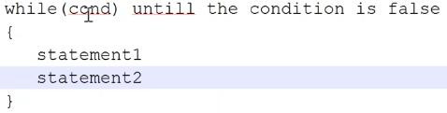

* It executes until the condition is false
* If condition is always true. Then it is called infinite loop

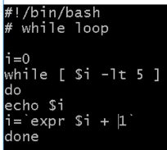

* As above, it checks I value by adding 1 to it up to I less than 5
* The output as below

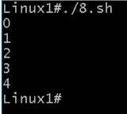

* If we add set-x inside the script as below. Then the script will run in debug mode. We will get to know what’s happening while running the script

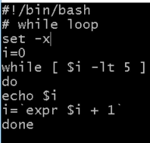

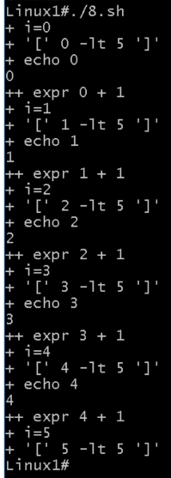

* As above, i=0 assigned then expr 0+1 means i=2. 2 is less then 5 so true that why I value printed. Like this it continues till the false statement

We can also use debug as below

* **Sh -vx script.sh**

This will be useful to know where the script is failing

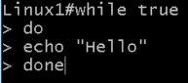

* As above, it will be like infinite loop where it will never end. While loop ends if there is a false statement

**For loop:**

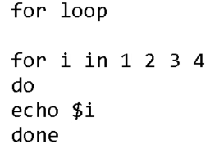

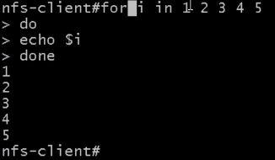

* For loop prints all the arguments in a list

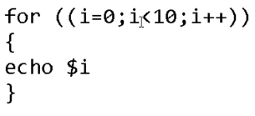

* Above example also works, it prints the I value until it is less than 10

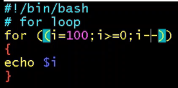

* This will print I value 100 to 0

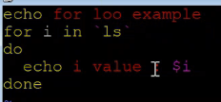

* In for loop, as above it will run ls command and prints the output as below

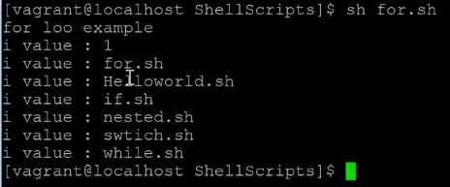

**Functions:**

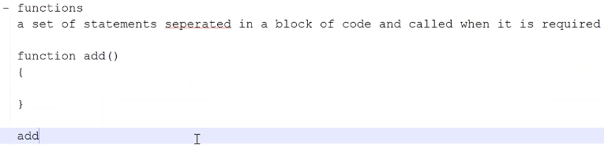

**Example:**

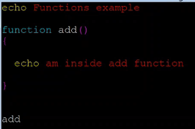

* As above, we are just adding function and calling it
* The output will be as below

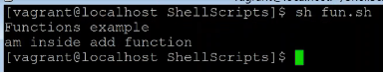

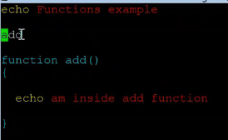

* If we add function as above, it will fail as because shell scripting is interpreter language. It scans line by line

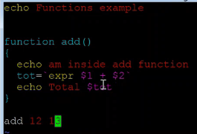

* Above example is called as function with parameter

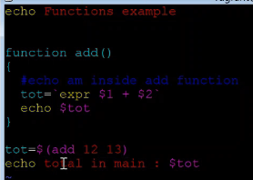

* Above example is called as function with return
* As above, 12 and 13 will be taken as value of 1 and 2

**Another example:**

